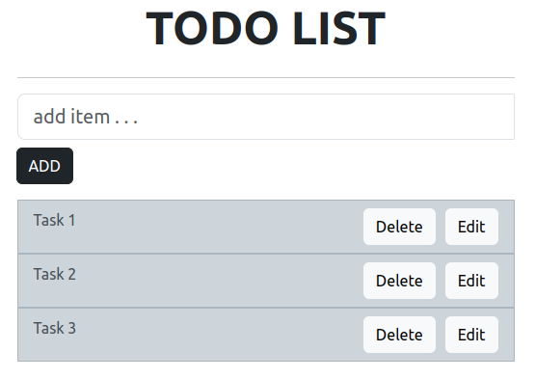

**Steps to create the Application:**

npx create-react-app todo-react

cd todo-react

npm install bootstrap

npm install react-bootstrap

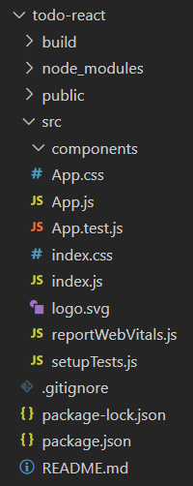

The dependencies in **package.json file**will look like:

"dependencies": {

"@testing-library/jest-dom": "^5.16.5",

"@testing-library/react": "^13.4.0",

"@testing-library/user-event": "^13.5.0",

"react": "^18.2.0",

"bootstrap": "^5.3.0",

"react-bootstrap": "^2.7.4",

"react-dom": "^18.2.0",

"react-scripts": "5.0.1",

"web-vitals": "^2.1.4"

}

Write the below code in App.js file in the src directory

* javascript

|  |
| --- |
| // App.js File  import React, { Component } from "react";  import "bootstrap/dist/css/bootstrap.css";  import Container from "react-bootstrap/Container";  import Row from "react-bootstrap/Row";  import Col from "react-bootstrap/Col";  import Button from "react-bootstrap/Button";  import InputGroup from "react-bootstrap/InputGroup";  import FormControl from "react-bootstrap/FormControl";  import ListGroup from "react-bootstrap/ListGroup";    class App extends Component {      constructor(props) {  **super**(props);            // Setting up state  **this**.state = {              userInput: "",              list: [],          };      }        // Set a user input value      updateInput(value) {  **this**.setState({              userInput: value,          });      }        // Add item if user input in not empty      addItem() {  **if** (**this**.state.userInput !== "") {              const userInput = {                  // Add a random id which is used to delete                  id: Math.random(),                    // Add a user value to list                  value: **this**.state.userInput,              };  // Update list              const list = [...**this**.state.list];              list.push(userInput);                // reset state  **this**.setState({                  list,                  userInput: "",              });          }      }        // Function to delete item from list use id to delete      deleteItem(key) {          const list = [...**this**.state.list];            // Filter values and leave value which we need to delete          const updateList = list.filter((item) => item.id !== key);            // Update list in state  **this**.setState({              list: updateList,          });      }  editItem = (index) => {        const todos = [...**this**.state.list];        const editedTodo = prompt('Edit the todo:');  **if** (editedTodo !== **null** && editedTodo.trim() !== '') {          let updatedTodos = [...todos]          updatedTodos[index].value= editedTodo  **this**.setState({            list: updatedTodos,        });        }      }        render() {  **return** (              <Container>                  <Row                      style={{                          display: "flex",                          justifyContent: "center",                          alignItems: "center",                          fontSize: "3rem",                          fontWeight: "bolder",                      }}                  >                      TODO LIST                  </Row>  <hr />                  <Row>                      <Col md={{ span: 5, offset: 4 }}>                          <InputGroup className="mb-3">                              <FormControl                                  placeholder="add item . . . "                                  size="lg"                                  value={**this**.state.userInput}                                  onChange={(item) =>  **this**.updateInput(item.target.value)                                  }                                  aria-label="add something"                                  aria-describedby="basic-addon2"                              />                              <InputGroup>                                  <Button                                      variant="dark"                                      className="mt-2"                                      onClick={() => **this**.addItem()}                                  >                                      ADD                                  </Button>                              </InputGroup>                          </InputGroup>                      </Col>                  </Row>  <Row>                      <Col md={{ span: 5, offset: 4 }}>                          <ListGroup>                              {/* map over and print items */}                              {**this**.state.list.map((item, index) => {  **return** (                                    <div key = {index} >                                      <ListGroup.Item                                          variant="dark"                                          action                                          style={{display:"flex",                                                  justifyContent:'space-between'                                        }}                                      >                                          {item.value}                                          <span>                                          <Button style={{marginRight:"10px"}}                                          variant = "light"                                          onClick={() => **this**.deleteItem(item.id)}>                                            Delete                                          </Button>                                          <Button variant = "light"                                          onClick={() => **this**.editItem(index)}>                                            Edit                                          </Button>                                          </span>  </ListGroup.Item>                                    </div>                                  );                              })}                          </ListGroup>                      </Col>                  </Row>              </Container>          );      }  }    export **default** App;  **Steps to run the Application:**   1. **in terminal**   **npm start**   1. **In browser**   http://localhost:3000/ |
|  |